

A step-by-step maturity model for service provider ICT infrastructure and cloud transformation

September 2015

# Contents

Introduction 3

Executive summary 3

Defining the Road: Why service providers need to transform 4

Choosing the path: Service providers will benefit from ICT convergence 8

Begin in the data center: A service-driven data center framework 10

Conclusion 15

About TBR 16

For more information 16

**Service Provider ICT Infrastructure and Cloud Transformation**

# Introduction

Telecommunication service providers have unique challenges and opportunities to transform from network-centric, utility-like business models that limit growth, to new business models that increase revenue by operating with the flexibility of a converged ICT infrastructure that enables mission-critical cloud services for enterprises and new digital services. Additionally, they can use a wide array of network and data center transformation technologies to make this transition while increasing profitability.

This white paper describes a step-by-step maturity model for ICT transformation to enable cloud services. It also highlights the issues service providers face in the current business environment.

# Executive summary

To successfully transform to more lucrative business models, service providers have to tackle a set of strategic and tactical initiatives. Recent TBR studies of Tier 1 service providers reveal that executives in operations and IT recognize the problems and opportunities and are steering their organizations down the transformation road. Some of the key initiatives they are driving include:

* **ICT infrastructure transformation benefits:** Service providers have the opportunity to address solution gaps to meet market demand for superior quality of service and innovation for consumer and enterprise services. These gaps exist because cloud and digital content providers lack the control mechanisms to associate services with the network infrastructure. Telecom service providers have the ability to address the gaps by transforming their infrastructure from independent communications and IT silos to converged ICT platforms that seamlessly cater network and IT parameters to the requirements of the enterprise or consumer. This advanced service provisioning can provide end customers with quality of service levels not available in today’s market.
* **Transformation obstacles**: Creating a converged ICT infrastructure is challenging for several reasons. The transformation needs to occur while network and IT systems are still in production delivering today’s services. It also depends on relatively immature technologies to obtain convergence and reap the full benefits of transformation.
* **Step-by-step maturity model is required to transform:** A step-by- step maturity model will help service providers overcome transformation obstacles. This model includes setting a strategic target of a converged and multitiered ICT cloud infrastructure. The strategy begins in the data center, where IT and network platforms are converged to become virtualized ICT platforms, combining servers, storage and networking services. Advanced implementation will enable a shared, service-enabled infrastructure.
* **Monetizing the infrastructure through customer experience design:** With the converged ICT infrastructure in place, self-service portals can be created for businesses and consumers. These portals will access service catalogs of network functions that provide dynamic experience management. This programmable platform automatically distributes content and processing where it is needed based on customer demand and the business model the service provider chooses.

**Defining the road: Why service providers need to transform**

Customers flock to open digital ecosystems for greater content and services access

For the first 100 years of telecommunications, the industry has relied on a business and technology model that locked subscribers into a single operator’s network enabling voice and data services. Within the last 15 years, new competitors have arisen with Internet-enabled open business models. Rather than locking in subscribers, these competitors rely on providing the best customer experience. Instead of closed networks and controlled services, the new model relies on providing open access across the digital ecosystem — the more open, the greater the access and the wider the variety of content and services available to the customer. Alibaba, Amazon and Google are the largest players in this new model.

These firms connect the customer to any and all possible Internet-enabled experiences, within the digital ecosystem (e.g., search, video and social media) and across physical and digital experiences (e.g., e-commerce and travel bookings). Increasingly, they also connect businesses to each other for design, supply, manufacturing and sales and to their customers. Specialists have arisen to capture key segments within these new models such as Facebook and LinkedIn (i.e., social media) as well as Salesforce (i.e., sales support automation). These brands far outweigh telecom service providers when customers think about the value of the digital ecosystem.

Customers expect real-time customizable services on demand

Telecom service providers responded to this shift in customer behavior by at first competing with the new players through their “walled gardens” of digital content. Customers rejected the controls imposed by the gardens approach, as they believe it limited their freedom of choice. Providers then surrendered to the demand for open access by serving as the on-ramps to the digital services of the new players, first for all forms of digital content and increasingly for cloud services as well.

Working in parallel with the new players, service providers have continued to raise customer expectations by offering faster real-time connectivity, do-it-yourself service options and on-demand service performance. However, the monetization of this improved customer experience has been split unevenly. New players retain the bulk of the digital content revenue, while service providers remain limited to obtaining network and data access fees. Because of the competition among providers in key regions, price wars have continued to lower these access fees, reducing service provider profit margins even as data traffic transport costs continue to increase as data volumes grow exponentially.

In short, market dynamics have created an appetite for real-time customizable services on demand among customers, but new players are getting all the credit and most of the financial value while service providers struggle to avoid becoming utilities.

Service providers will transform to shift the balance

Service providers have the opportunity to transform their business and technology models to shift the balance in their favor. Customers are ready for the next level of experience, where they can access real-time customizable services on demand and take advantage of differentiated network connections that conform to their personal and company requirements. In essence, they can obtain the best of both the network and the digital services they want to consume, rather than acquire services from a menu of one-size-fits-all digital services offered in today’s market. Service providers can cater their offers to a per-service, per-user model in ways new players cannot.

Service providers are positioned uniquely to offer a truly personal customer experience

Service providers can align digital services from the open ecosystem to the customer’s subscriber identity and specified network requirements. By integrating IT data management with network provisioning and service delivery, service providers can offer the customer a unique, yet open experience. This is different than the undifferentiated, open digital experience new players offer.

Previously, this differentiated customer experience was called “personalization”; but the personalization offered today is not personal. It is simply developing automated responses based on the self-declared characteristics of the digital service customer. True personalization is using the combination of subscriber, network and digital service preferences to offer a unique customer experience. This service innovation is within the telecom service provider’s grasp if the provider transforms to enable it.

Service providers can transform and increase profitability

Thanks to virtualization and automated management technologies, service providers can deliver unique service innovation to customers at lower costs. Through automation and orchestration of network functions triggering programmable transport provisioning, service providers can deliver more personal experiences at a lower operating cost than running the old manual, closed model.

Higher revenue from acquiring and retaining more customers through service differentiation while lowering operating costs is a recipe for higher profit margins. The next decade will see the fruition of this transformation to a new service provider business and technology model.

**Challenges to transformation**

Service providers face a number of challenges when transforming from existing business and technology models to new personal service delivery models. They have to start with a strategic determination to refocus the business beyond being the best network. Focusing on the network alone leaves the service provider out of the digital value chain. Large multinational service providers recognize this, as many of them continue to invest in and brand themselves as the provider of the best network. At the same time, they are broadening their spending to acquire properties in video, advertising and content delivery and expanding cloud and Internet of Things services to the enterprise and small business. As they begin this transformation, they face internal technology architecture and organizational challenges.

Service providers must break down the silos and build ICT resource pools

Traditionally, service providers built technology architectures to match their service control models. This involved independent services deployed on their infrastructure of servers, software and storage, and integrated with central billing and management systems so they could be provisioned over the fixed or mobile network. A good example of this was SMS, the popular text messaging system built as an independent service and bundled with voice and Internet access as its revenue stream. Subscribers were given no choice but to use this bundle. This model worked well until alternative free and paid text messaging from the new digital players became prevalent. This shift has led to today’s state of SMS, where revenue from traditional messaging services is flat to declining, with growing encroachment by digital players. Service providers that remain focused only on voice, SMS/MMS and providing an on-ramp for Internet access are excluded from the $57 billion digital content business.

In most regions, service providers cannot become a household digital service brand overnight, but they can transform the network to allow a greater role in the digital service ecosystem. To do this, they need to transform their architectures from one infrastructure silo per service to a data center-oriented virtual resources environment where services are separated from the network functions they require and network and IT resources are pooled for maximum efficiency. As an executive from British Telecom put it, the architecture must shift from a catalog of dedicated services to a catalog of pooled network functions and IT resources. This ICT resource pool can then enable existing and new services, providing features such as personalization or bandwidth on demand for virtually any service at carrier-grade reliability and scale.

This transformation requires a new architecture of pooled resources, virtual functions and software-defined, programmable transport systems. Once this ICT resources pool is in place centrally and regionally, services can be deployed as necessary to allow service providers to adapt them to the personal needs of customers, including type of access, quality of access and digital brands in which they are interested.

Service providers must manage the risk of transformation

In the recent TBR *Telecom Software Mediated Networks (NFV/SDN) Customer Adoption Study,* service providers cited the organizational challenge of retraining staff and the integration of legacy and new infrastructure as the greatest obstacles to transformation. Other challenges included how to determine where to begin the transformation journey; developing and implementing a distributed, shared, virtualized IT infrastructure; and how to integrate new layers of management with existing OSS and BSS.

The challenges are evident in early adopter deployments, such as those at Telefonica, where the IT quality of service expectation based on interchangeable pooled virtual resources conflicts with the dedicated resources service providers are used to relying on for service delivery. However, the architectural solutions are available based on the expertise of ICT suppliers that understand the cloud delivery model and the traditional telecom model. TBR’s studies show most Tier 1 service providers expect the challenges to transforming to NFV and SDN to be resolved within the next two years.

Service providers must envision new models

Beyond the challenges of silo-busting and legacy migration, service providers need a new operating model that caters to rapid service innovation from within and outside their organizations. To truly acquire a more powerful position within the digital ecosystem, service providers require a two-sided operating model, where one side caters to the personal services of each subscriber and the other side caters to the unique needs of third-party developers. It is this matchmaking between application and service developers and the individual subscriber that is a key value the service provider can leverage and build a two-sided revenue model around.

The two-sided operating model is enabled by the flexibility and agility of the ICT resource pool. In addition to the virtualization of network functions and the programmability of transport, service providers must include a DevOps approach to creating new services. The DevOps model opens the resource pool to developers who can craft application or service function in parallel with production-ready resource identification. The ability to deliver and fast-fail or, even better, fast-succeed with service innovation is a critical feedback loop for developers and can improve time to market for service providers.

The two-sided model is not limited to third-party developers. The model also serves as a stronger mechanism for service providers to participate in the digital ecosystem with branded content providers that will see value in the speed of innovation, personal service model with subscribers and large-scale capabilities of service providers. While differentiated content models that require catered network access are limited in some countries due to net neutrality, in many countries there are no such limits.

In net-neutrality environments service providers are also acquiring stakes in the digital content to gain value from generic content delivery directly. For those providers, increased efficiency is possible as the principles of DevOps and ICT resource pools can extend from content creation through delivery across the value chain.

**The value of cloud transformation**

The value of transformation is twofold.

1. Reducing the total cost of ownership of the infrastructure: This is accomplished with easier operation and more efficient management. The keystones of operational efficiency are driven by the elimination of silos on the network and IT platforms to create a common converged platform. This reduces operational duplication. Additionally, the single converged services platform is more easily automated, and thus managed with greater ease and efficiency.
2. Increasing the flexibility of services: These benefits include more agile service provisioning and easier scalability. Once a converged platform is in place, the provisioning and scalability of services is enabled by accessing common resource pools, which greatly reduces the time and cost of service delivery,

Ultimately, the telecom service provider operates more like a cloud service provider, but with the advantage of owning the network, which enables a two-sided revenue model. The two-sided model generates revenue from subscribers for standard access and value-added personal services as well as from the branded content provider or third-party developer through revenue sharing and advertising.

|  |  |
| --- | --- |
| Benefits of Transformation | |
| Asset utilization | Economies of scale of cloud computing model across ICT platforms combined with higher hardware utilization and network optimization |
| Lower operating costs | Less hardware means lower power costs, and more automation means lower man power investment. |
| Lower capital costs | Less hardware means lower capex, and ease of scaling means capex costs can be kept down even as traffic grows. |
| Greater resiliency with less redundancy | Failures are managed by spinning up new instances of services on virtual machines, requiring less-redundant systems to guarantee reliability. |
| Faster service delivery | Common services platform enables quick response to service provisioning requests. |
| More value for the customer | Faster services, more service choice and greater service quality improve customer acquisition and retention. |

Source: TBR

Faster time to market for services

In the traditional model, months or years were acceptable as the time line to roll out new services. This long lead time was supported by the scale, permanency and strong likelihood of a viable revenue stream from a large, captive subscriber base. This “build it and they will adopt” business case was supported by significant incentives and marketing support, often driven by parallel upgrades in devices or network connections.

The transformation to a cloud-like ICT resource pool will not only open new streams of revenue for the service provider, but it will also reduce the cost of obtaining that revenue. One chief cost-reducing element will be faster time to market for new services.

Overall, total cost of ownership reduction will increase after the first few years of ROI realization because the total infrastructure for service providers will migrate to a much smaller base of network and IT equipment, which will reduce support and upgrade costs but shift costs to a large base of software, much of which will be virtualized platforms.

**Choosing the path: Service providers will benefit from ICT convergence**

To successfully migrate to new business and technology models, service providers need to choose a different path for transforming their infrastructure than previously. In the past, software and hardware upgrades for new services or new capacity were implemented in separate stacks of closely integrated components for each service or domain. In the new ICT resource pool model, these components will be converged not only aggregating network functions, but also pairing them with service chains of converged IT functions and resources.

Service providers are taking different paths to ICT transformation. Most are starting in the data center with IT virtualization and consolidation, and then staging network functions within the data center to create a complete converged infrastructure. Another path is to create an external cloud platform, then gradually merge internal network functions within the cloud model. Finally, some service providers prefer a network-centric approach, where network elements are being virtualized on a per-domain basis.

**Figure 1**

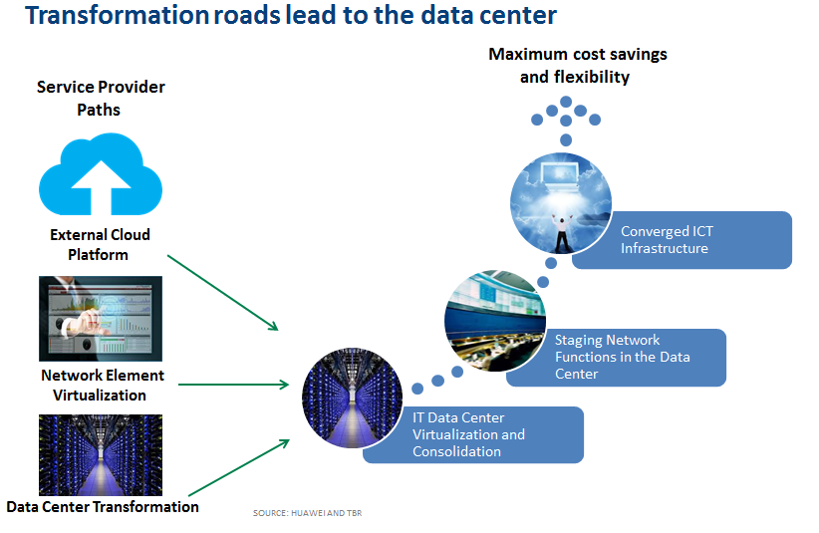

In all cases, virtualization and consolidation of elements and IT systems are key, followed by some form of convergence, whether the center point in the data center, the cloud platform or the network. Once virtualized, converged and consolidated, these platforms are ready for the common steps of automating management and provisioning to improve service delivery speed and capability.

ICT convergence enables a broader service portfolio

Prior to ICT convergence, siloed communication network services required expensive dedicated infrastructure, which were difficult and slow to upgrade. These CT infrastructures were largely focused on real-time voice and messaging services and had difficulty adapting to multimedia and Internet-based services. On the data center side, IT infrastructure was underutilized and equally complex with independent resources that were difficult and expensive to scale with long provision times.

Service providers were reluctant to add new services without guaranteed scale due to difficult, expensive systems, so roll out of service innovation across this complex infrastructure became nearly impossible. ICT convergence unified CT and IT systems across a common cloud-based architecture where key network functions are virtualized and aligned to resource pools of compute and storage capacity. These technologies are complemented by a software-defined transport infrastructure that can be programmed according to the service requirements.

The benefits of ICT convergence then are comparable to the benefits of a unified cloud architecture, where the cost of scaling up resources or scaling out service functions is dramatically lower because it is automated and orchestrated across standard common platforms across a network of cloud-enabled data centers.

Transformed service providers will also improve their business reputation, becoming cloud-savvy digital players rather than slow-moving telcos. This transformation will improve service providers’ opportunities to retain their customer bases and broaden sales channels. Finally, revenue will increase, as the service provider can leverage this advantage to promote new digital services, especially to government enterprise customers.

ICT convergence supports service provider differentiation

In addition to the cost and speed-to-market advantages of ICT convergence, service differentiation is enabled by the twin capabilities of personalization of integrated digital and network services and the ability to onboard and fast-fail or fast-succeed with innovative services from internal and external developers.

Differentiators are enabled by a converged ICT infrastructure that supports integrated server, storage and network operations for cloud services. Not only are these cloud services suitable for conventional cloud applications, but because the production network is also integrated, network-enhanced services and applications that cater to the customer experience can be delivered.

**Key characteristics of a successful transformation**

Service providers will have achieved successful ICT infrastructure and cloud transformation when they obtain the following benefits:

* Maximum network efficiency: Beyond the best network, this characteristic allows the operations and maintenance of the network to operate with efficient capacity utilization and ease of scaling to meet traffic and quality of service requirements.
* Customer experience-driven services: Self-service portals for enterprises and consumers trigger standard and customized services capabilities that are fulfilled automatically within the network. The response time is immediate, with accurate billing and metering of the service as well as compliance to regulatory, SLA and security characteristics.
* Third-party revenue sharing: The network and ICT infrastructure are able to integrate easily based on standard APIs with third-party developer and digital service provider offers to enable revenue-cost sharing models. This characteristic enables the service provider to target different industries and differentiate through joint service innovation.

**Begin in the data center: A service-driven data center framework**

Simplifying the ICT convergence transformation process requires breaking it down to broad categories. Initially, an overall target architecture should be set. To address the personal service model, this architecture should be cloud-based with the objective of creating a common ICT resource pool and customer-centric service delivery environment. To accomplish this process, infrastructure, operations and service delivery must be transformed into a tightly integrated but flexible environment for new and existing services.

A service-driven data center implements distributed resource sharing and centralized resource management, and builds multiple data centers with flexible performance, security features and SLA levels to adapt to operations and management support, network services, public cloud services, and other scenarios. Examples of such scenarios are:

External services

* Public cloud services that require IT systems for a large number of tenants
* Digital services that require responsive on-demand service design and provisioning
* Private cloud hosting for government and enterprise customers that require customized security and reliability

Internal services

* IT systems supporting BSS and OSS that require big data and elastic scaling
* IT systems serving telecom networks that need to provide carrier-class performance and availability.

**Data center maturity**

The state of the data center will determine the flexibility of the service delivery, so it is possible to understand ICT data center evolution as a series of steps in maturity, as shown by the Figure 2.

**Figure 2**

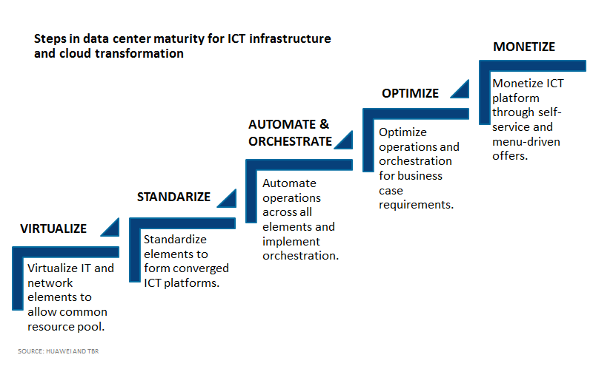

Step1: Virtualize

To enable dynamic provisioning, the data center must be virtualized. Virtualization allows the dynamic allocation of resources. The traditional configuration constraints of forced binding of infrastructure and software must be changed to support dynamic demand requirements. Service providers must first virtualize and consolidate data centers, which are at the core of the new ICT architecture. Physical facilities must be consolidated and located appropriately based on the geography and capacity needs of the service provider. Telefonica, for example, is consolidating its multiple local data centers into regional centers covering its European and Latin America infrastructures and operating units. Logical virtual data centers must be established within the physical infrastructure to centralize management of IT resource distribution, abstract resources and create resource pools that can be dynamically provisioned or scaled.

Within each data center, many service providers have committed to full virtualization, including:

* Server virtualization, which provides workload balancing and data protection as well as increasing utilization;
* Storage virtualization, which creates a pool of disk space that can be provisioned from any server.

At this level, service providers leverage the power of virtualization to manage computing resource using hypervisors. While this implementation can increase hardware resource utilization and simplify resource management and provisioning, it includes minimal automation mechanisms at the earliest stage of maturity.

Requirements to accomplish this stage include virtualized server and storage infrastructure and operations supported by knowledgeable operations personnel. This includes basic infrastructure monitoring components for physical and virtual server, along with basic IT event, incident and problem management tools. Operations should be able to plan virtualization and capacity based on a single virtual machine and application level. There should also be basic virtualization security mechanism such as anti-virus and centralized logging for all components.

Step 2: Standardize

The design of each ICT infrastructure layer must be standardized. The value of virtualization will be lost if the service provider recreates a collection of virtualized silos, each requiring unique integrated and abstraction approaches. Standardization unifies resources so a common abstraction layer can be deployed. Standardization across this virtual and physical architecture is required to maximize efficiency. There will likely be multivendor equipment and management systems, but conformity to standard specifications such as OpenStack to ease the creation of interfaces and integration for abstraction and orchestration layers is critical.

At this level, service providers are able to offer cloud services (e.g., IaaS) and provide automated provisioning. A standard cloud service catalog, as well as customized services, may be in place. These services are supported by standard resource and service measurements. Standardized services eliminate repeated manual labor, reduce IT system management complexity and increase system usability.

At this stage, requirements include the ability to manage, customize and release products through a standard service catalog. Users are able to buy the required products through the service catalog. This improves quality and efficiency of service selection and delivery.

Service standardization is enabled at the virtualization layer through virtual machine templates definition, unified management, and image creation and management. Each service specification is established for basic configuration and automation. These mechanisms support self-service portals, enabling multiple virtual servers and storage resources to be automatically configured based on the demand. Usage metering is also enabled, as all provisioned infrastructure is monitored and usage is reported. This supports efficient capacity allocation and planning.

Step 3: Automate and orchestrate

At its advanced stage, the mature ICT infrastructure provides an automated management platform that dynamically scales on demand, uses converged ICT resources and relies on standards-based multivendor abstracted components. Once the infrastructure is in place to operate in a consolidated, cloud-enabled fashion with end-to-end integration, network operations can be automated. The combination of creating an abstraction layer built on virtualized functions enables the service provider to create automated responses to delivering and maintaining services without directly altering the physical ICT infrastructure. Finally, the ICT infrastructure can be orchestrated with a layer of management tools that use policies to activate a set of interconnected automated network services to align with business processes. The orchestration layer is perhaps the most important, as it defines policies and service levels through automated workflows that make service provisioning and change management far more efficient than previously. A well-orchestrated ICT infrastructure provides the cost-effectiveness, flexibility and responsiveness the new model requires.

At this level, a service provider is able to standardize cloud services automatically with greater efficiency. Automation and orchestration management tools improve monitoring, security and business continuity. At this level, IT transforms from a support center to a revenue center by providing differentiated cloud and virtual data center service, which consolidate computing, storage, network and other resources into a pool to be applied to meet service-level and quality assurance agreements for different business needs.

At this level, service providers focus on building standardized cloud infrastructure architecture to enable virtual data centers with different performance, security and availability requirements for critical business needs. This can include development and test zones as well as multitenant support. The management tools at this level support monitoring that integrates bill and account access, and chargeback and cost recovery components based on resource and service metering. Ultimately, this level allows enhanced IaaS services based on self-service portals with integrated life cycle management and service-level agreement options; other characteristics include cloud monitoring with automatic event alerts and responses, a change management process for virtualization and cloud computing, capacity management with service impact analysis and service growth prediction, and a strong security protection system in the cloud and in the legacy domain. The level of security can be increased based on the requirements of a cloud environment.

Step 4: Optimize

The entire ICT infrastructure is then defined as a service — an interconnected set of services enabling automated workflows. This not only supports the construction of a catalog of functions that can be aligned with any dynamically provisioned service, but it also supports service-level agreements that can be enforced through policies in real time and measured and calibrated to improve customer service. After finalizing the ICT infrastructure, including key decisions such as centralization and regionalization of a data center, such as where resource pools and network access and aggregation nodes should be located, the entire infrastructure base should be assessed for maximum optimization. Current and future workloads should be assessed along with the efficiency of resource utilization and network path optimization.

At this level, multilocation, multidata center IT system management is achieved to support hybrid cloud management or support service scheduling across data centers. This level is vital to achieve the software-mediated network. The service provider can offer an interface to external public clouds and can process peak workloads coordinated with external public cloud to process them at the optimal location.

The optimized maturity level should integrate with the enterprise information technology infrastructure library (ITIL), including IT asset management, license management, change and configuration management, and service-level agreement management. Every change of the infrastructure should match with the corresponding management process, controlled by event management.

Service orchestration and choreography should be established through combined hardware and software components. Business processes are managed and maintained automatically. These can range from creating virtual servers according to the service need or creating IT on-demand services. A single self-help service choreography interface is required to provide service for cross-data center and complex computing and storage systems. Middleware service supply management systems are also in place.

Service providers can support hybrid cloud management with the availability of shifting secondary workload to the third party by using the external cloud computing resources (e.g., public cloud). Data can be migrated between the public cloud and private cloud to optimize high-performance resource utilization at the lowest cost investment.

Step 5: Monetize

Given the advanced ICT infrastructure supported by a data center framework, the service platforms can then be aligned to maximize monetization. This can come from interfaces or third-party content providers, developers or end customers, essentially opening up the power of dynamic service provisioning, innovation and consumption to the end customer or to valued digital ecosystem partners. The service-enabled infrastructure becomes service-driven, which takes the steps outlined so far to the next level. Once ICT resources have been virtualized, pooled, linked to be activated through automated workflows and orchestrated according to business policies, what determines what those policies should be? A network-centric answer may be that they should be aligned for efficiency, security and reliability. However, beyond these core requirements, they should be aligned to meet the service requirements of the end customers. This added level suggests new design thinking that informs policies from a top-down, demand-driven approach rather than a bottom-up, network-function approach. The service driven ICT data center is customer-driven rather than technology-driven, requiring an ICT infrastructure that can be provisioned dynamically to meet customer requirements in real time.

At this level, service providers can leverage cloud capabilities to transform IT to a service innovation center. They can provide various ICT services based on open cloud APIs, and differentiate services based on network requirements for the full ecosystem of business, infrastructure, and new digital services and vertical industrial solutions. This level also includes accounting, billing and management capabilities to support new revenue models. At this level service providers have established a service portal with comprehensive functions, including on-demand customization for monitoring, reporting and management. They can support various cost models based on service usage and have finite pricing units. The ICT infrastructure is integrated with BSS and CRM systems and can provide services with differentiated service agreements.

On a management level, the service provider operates with ITSM best practice processes and visual tools to support service desk, change, and configuration and capacity management. Security is key with a high-level protection system, covering facilities, infrastructure, data, OS, application, operation and management. These can be made to be fully compliant with regional and industrial security standards as well as regulatory requirements with automatic checking and recovery mechanisms. For example, the system could support single sign on and third-party federal identity management.

Implementation requirements

The process of implementing a transformation project is best understood as a series of life cycle phases. In addition to the typical migration project characteristics, ICT transformation includes procedures for establishing end-to-end ICT processes. These processes involve the network and the data center. Each component must be analyzed and well documented so their functions can be replicated in the target consolidated, virtualized architecture. Because the new platform will be different from the legacy platform, the new solutions will require significant continual testing and verification.

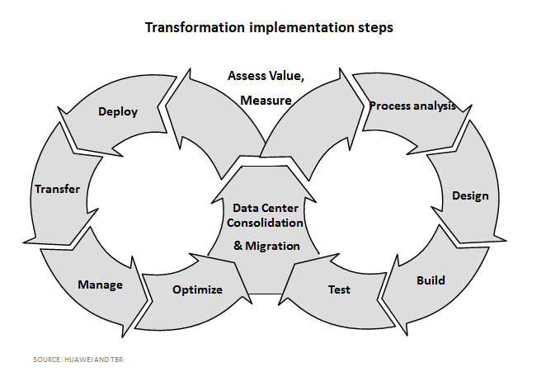

**Figure 3**

**Data center cloud maturity assessment model**

TBR and Huawei jointly release the following assessment model to evaluate the data center cloud maturity level:

|  |  |  |
| --- | --- | --- |
| Category | Metric | Description |
| IT Business | Accounting & Billing | Process focused on IT chargeback, ability to look at usage cost of services, and provide accurate billing and invoicing based on consumption |
| Risk Management | Process focused on proactive risk management and mitigation to provide service quality and continuity |
| Service | Service Catalog Management | Mechanism to offer services to customers |
| Service Level Management | Establishment, development, tracking and reporting of tiered service offerings with appropriate availability metrics; establishes OLAs to support SLAs |
| Operations | Monitoring, Event, Incident and Problem Management | Process to facilitate the timely restoration of service within agreed service levels; process manages the complete life cycle of an event from generation, prioritization and escalation to resolution and root cause analysis |
| Change Management | Process focusing on reduction of risk from changes; helps achieve minimal operational overhead |
| Capacity Management | Continual process to provide capacity availability for delivered services (e.g., managing the rightsizing of a vCenter cluster or organization virtual data center) |
| Availability and Continuity Management | Process to manage the availability of delivered services (makes sure service levels can be met from an availability perspective and managing availability breaches) |
| Access and Security Management | Process to provide secure cloud and virtualization multi-tenancy zones that are compliant, trusted and audited |
| Infrastructure | Infrastructure Architecture | Process for developing and maintaining the cloud and virtualization environment architecture; facilitates adherence to corporate standards and integration with overall enterprise architecture |
| Infrastructure Deployment | Process for repeatable and reliable implementation of cloud and virtualization architecture |

Source: Huawei And TBR

# Conclusion

# To date, a handful of Tier 1 service providers have begun the journey to ICT infrastructure transformation. TBR surveys indicate this is core to their strategy, and we believe once advantages from this new model manifest in lower costs and increased revenue, the rest of the service provider market will follow.

**About Huawei**

Huawei is in a leading position with its service-driven data center solution, which rests at the core of its broad product and services portfolio of ICT infrastructure and transformation capabilities. Companies such as China Mobile, Telefonica and Star Hub in Singapore as well as government, utilities, energy, transportation, finance and Internet service providers have taken advantage of Huawei’s data center capabilities.

**About TBR**

Technology Business Research, Inc. is a leading independent technology market research and consulting firm specializing in the business and financial analyses of hardware, software, professional services, telecom and enterprise network vendors, and operators.

Serving a global clientele, TBR provides timely and actionable market research and business intelligence in formats that are tailored to clients’ needs. Our analysts are available to further address client-specific issues or information needs on an inquiry or proprietary consulting basis.

# For more information

TBR has been empowering corporate decision makers since 1996. For more information, visit [www.tbri.com](http://www.tbri.com/).

This report is based on information made available to the public by the vendor and other public sources. No representation is made that this information is accurate or complete. Technology Business Research will not be held liable or responsible for any decisions that are made based on this information. The information contained in this report and all other TBR products is not and should not be construed to be investment advice. TBR does not make any recommendations or provide any advice regarding the value, purchase, sale or retention of securities. This report is copyright-protected and supplied for the sole use of the recipient. ©Contact Technology Business Research, Inc. for permission to reproduce.